SIMATS ENGINEERING
SAVEETHA INSTITUTE OF MEDICAL AND TECHNICAL SCIENCES
CHENNAI – 602105
Department of Computer Science and Engineering

ASSESSMENT TOOL 1 – Dashboard Development Task

Course Code: | DSA0502 | Course Title: | Query Processing for Data Science
CO Assessed: | CO5 | Assessment: | Tool 3– Dashboard Development Task
Weightage: | 25% | Total Marks:
CO5 Statement: Create meaningful visualizations using Pandas and Matplotlib, including charts, distributions, relationships, and interactive visual representations for effective communication
Student Name: | G Rajasekhar Reddy | Reg. No.: | 192424216
Section / Batch: | B.Tech-AI&DS | Date of Submission: | 22/08/2026
Faculty In-charge: | Dr. B.Shyamala Gowri | Project Mode: | Individual Submission

Code of Conduct
I G. Rajasekhar Reddy(192424216) (Name / Reg No) certify that this submission is my original work and that I have adhered to all guidelines specified for this assessment. I understand that any violation of academic integrity rules will result in disciplinary action.
Signature: G Rajasekhar Reddy

1.Student Academic Performance Dashboard Develop an interactive dashboard using Pandas and Matplotlib to analyze student performance. Import a dataset containing attendance, internal marks, assignment marks, laboratory marks, and final scores. The dashboard should include bar charts, distribution plots, scatter plots, and frequency charts. Use a scatter matrix to study relationships between variables and identify performance patterns and outliers.
Aim:
To develop a dashboard using Pandas and Matplotlib to analyze student academic performance using attendance, internal marks, assignment marks, laboratory marks, and final scores.
Program:
import pandas as pd
import matplotlib.pyplot as plt
from pandas.plotting import scatter_matrix

data = {
"Student": ["S1", "S2", "S3", "S4", "S5", "S6", "S7", "S8"],
"Attendance": [90, 75, 95, 80, 65, 88, 92, 70],
"Internal": [82, 70, 90, 76, 60, 84, 89, 66],
"Assignment": [85, 72, 92, 78, 64, 86, 90, 69],
"Lab": [88, 68, 94, 75, 62, 85, 91, 65],
"FinalScore": [86, 71, 93, 77, 61, 85, 90, 67]
}

df = pd.DataFrame(data)

# Bar Chart
plt.bar(df["Student"], df["FinalScore"])
plt.xlabel("Student")
plt.ylabel("Final Score")
plt.title("Student Final Scores")
plt.show()

# Distribution Plot
plt.hist(df["FinalScore"], bins=5, edgecolor="black")
plt.xlabel("Final Score")
plt.ylabel("Frequency")
plt.title("Distribution of Final Scores")
plt.show()

# Scatter Plot
plt.scatter(df["Attendance"], df["FinalScore"])
plt.xlabel("Attendance")
plt.ylabel("Final Score")
plt.title("Attendance vs Final Score")
plt.show()

# Frequency Chart
df["FinalScore"].plot(kind="bar")
plt.xlabel("Student")
plt.ylabel("Final Score")
plt.title("Frequency of Final Scores")
plt.show()

# Scatter Matrix
scatter_matrix(
df[["Attendance", "Internal", "Assignment", "Lab", "FinalScore"]],
figsize=(10, 10),
diagonal="hist"
)
plt.suptitle("Scatter Matrix of Academic Performance")
plt.show()
Output:
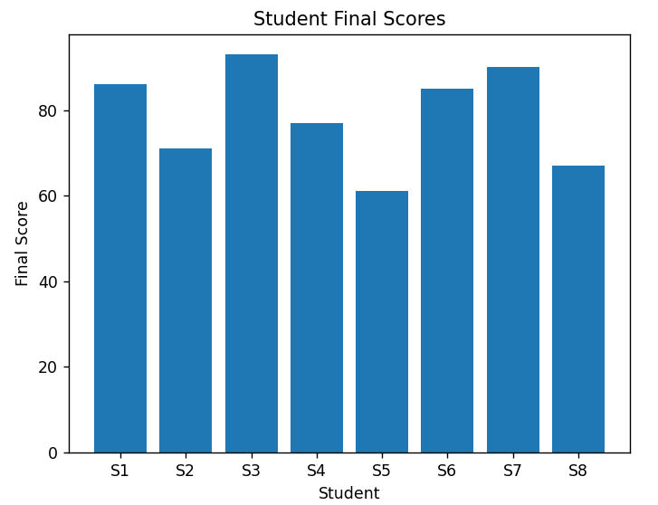

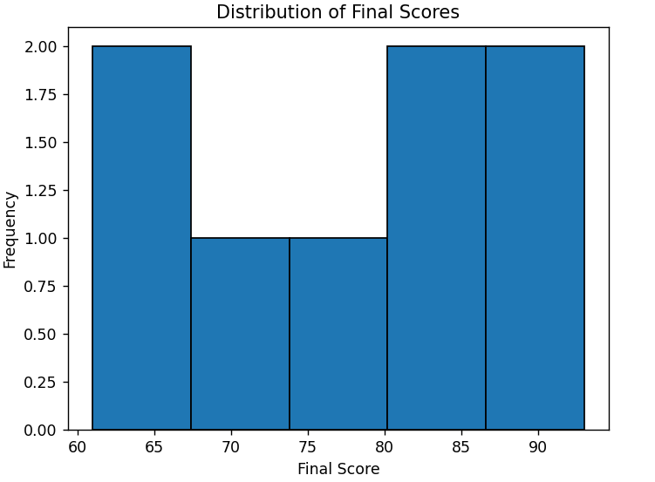
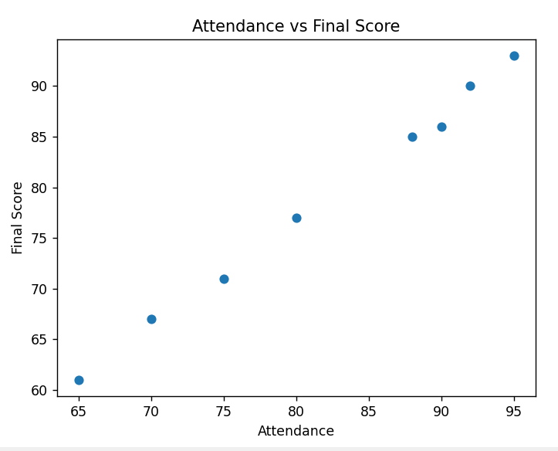
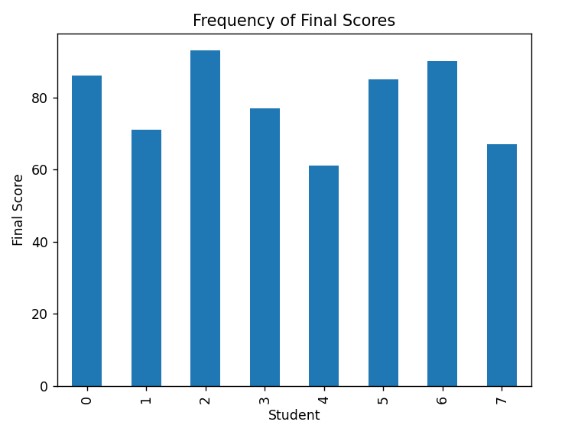

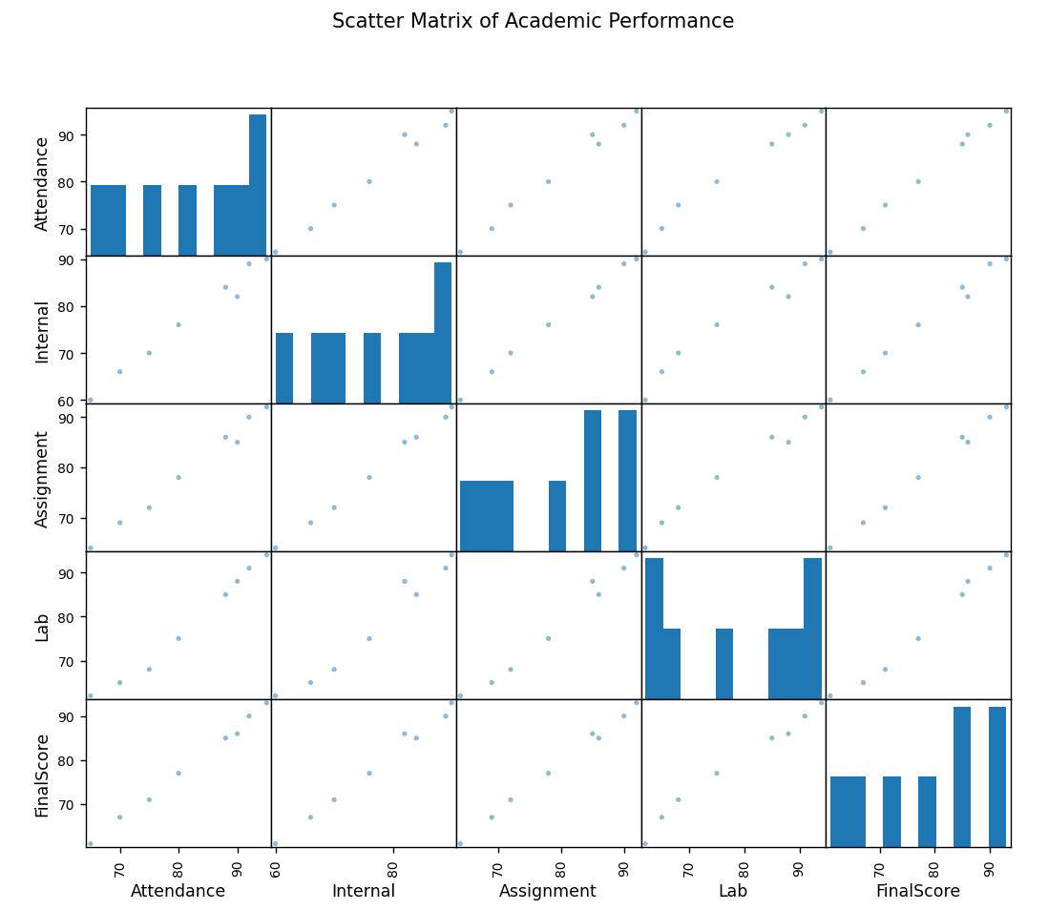

3.Employee Productivity Analysis Dashboard
Develop a dashboard to analyze employee working hours, experience, productivity score, salary, and performance rating. Use distributions and frequency plots to understand employee characteristics, scatter plots to identify relationships, and a scatter matrix for multivariable analysis. Identify unusual employee records using suitable visualizations.
Aim:
To develop a dashboard using Pandas and Matplotlib to analyze employee productivity based on working hours, experience, productivity score, salary, and performance rating.
Program:
import pandas as pd
import matplotlib.pyplot as plt
from pandas.plotting import scatter_matrix

data = {
"Employee": ["E1", "E2", "E3", "E4", "E5", "E6", "E7", "E8"],
"WorkingHours": [40, 45, 38, 42, 50, 36, 44, 48],
"Experience": [2, 4, 1, 5, 7, 2, 6, 8],
"Productivity": [72, 80, 65, 88, 92, 68, 85, 90],
"Salary": [35000, 45000, 30000, 55000, 65000, 34000, 58000, 70000],
"Performance": [3, 4, 3, 5, 5, 3, 4, 5]
}

df = pd.DataFrame(data)

# Distribution Plot
plt.hist(df["WorkingHours"], bins=5, edgecolor="black")
plt.xlabel("Working Hours")
plt.ylabel("Frequency")
plt.title("Distribution of Working Hours")
plt.show()

# Bar Chart
plt.bar(df["Employee"], df["Productivity"])
plt.xlabel("Employee")
plt.ylabel("Productivity Score")
plt.title("Employee Productivity")
plt.show()

# Scatter Plot
plt.scatter(df["Experience"], df["Productivity"])
plt.xlabel("Experience")
plt.ylabel("Productivity Score")
plt.title("Experience vs Productivity")
plt.show()

# Frequency Chart
df["Performance"].value_counts().sort_index().plot(kind="bar")
plt.xlabel("Performance Rating")
plt.ylabel("Frequency")
plt.title("Performance Rating Frequency")
plt.show()

# Scatter Matrix
scatter_matrix(
df[["WorkingHours", "Experience", "Productivity", "Salary", "Performance"]],
figsize=(10, 10),
diagonal="hist"
)
plt.suptitle("Scatter Matrix of Employee Data")
plt.show()
Output:
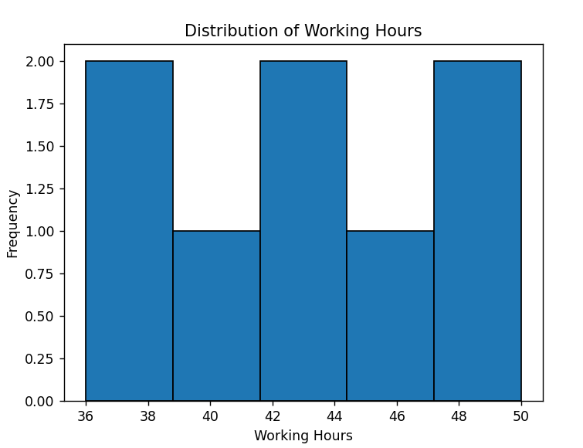
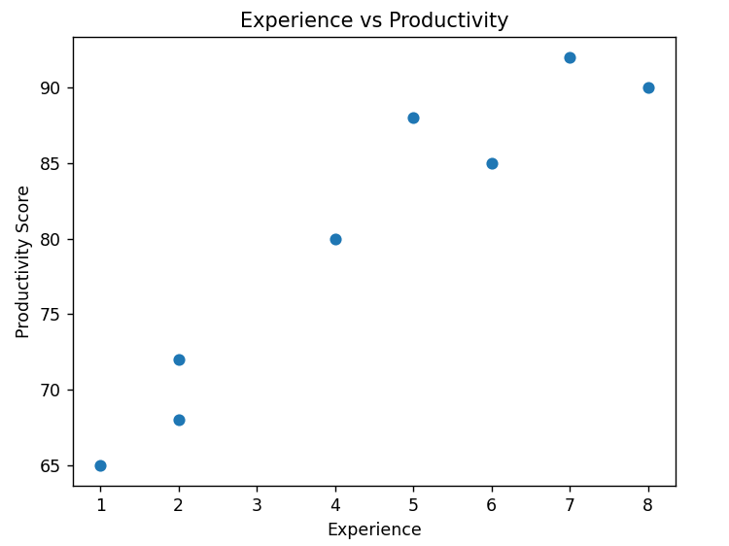
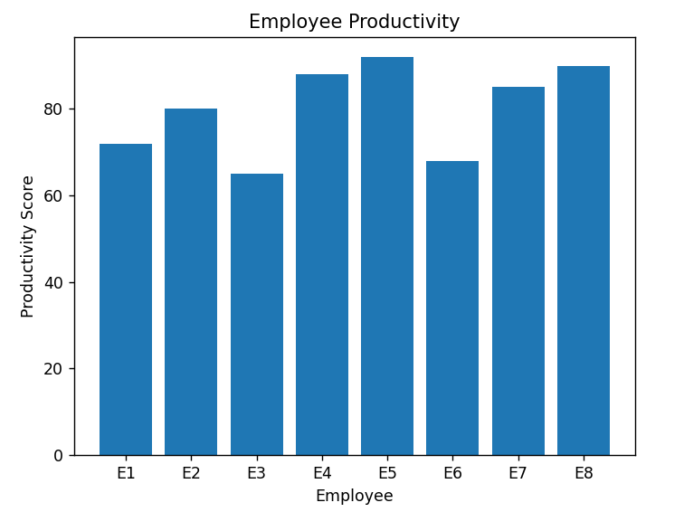
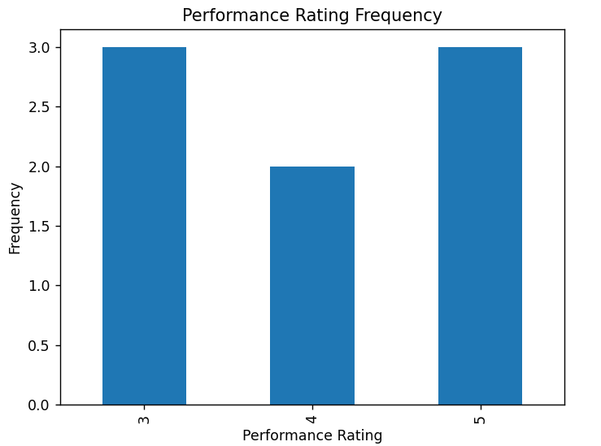
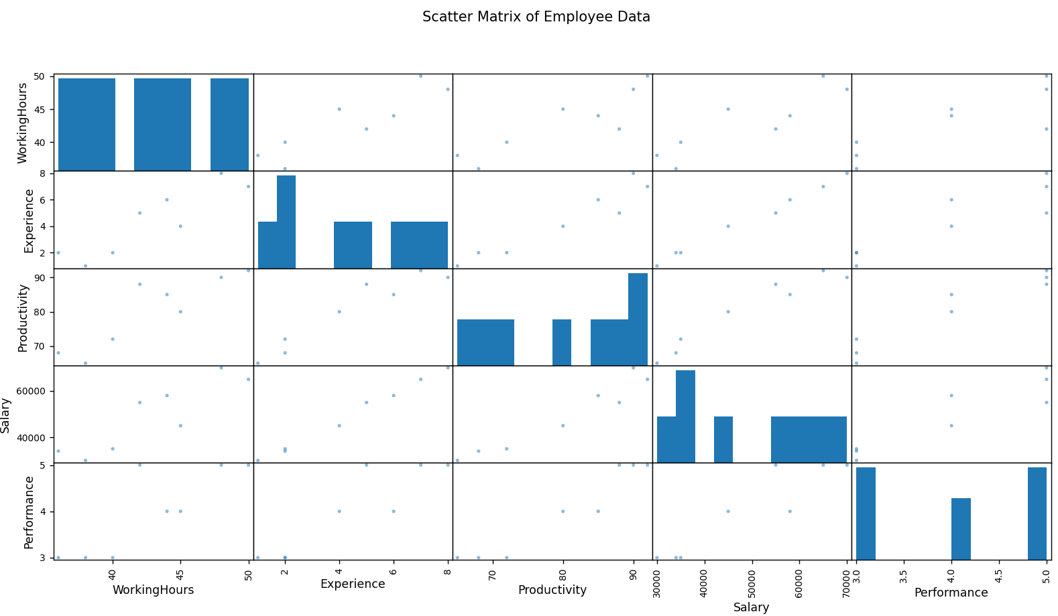

窗体底端

